THC# - Tinnitus Hyperacusis Center Sequence Number - a unique number assigned to each patient. Generated automatically by the system. It cannot be changed by the user.

1.5 Audiology Screen

This screen is used to enter/edit data related to audiological evaluation of a patient at a medical facility.

• **Upper panel:** inactive fields (auto-filled by the system):

– Patient’s name.

– Patient’s THC#.

– Visit’s sequence number for the patient.

– Visit’s Date.

• **Main panel:** active fields (filled by the user):

1–  Pure-tone audiogram tests for the right (R) and left (L) ear, in all frequencies in audiogram from 0.25 up to 12 kHz: R25, R50, R1, R2, R3, R4, R6, R8, R10, R12, L25, L50, L1, L2, L3, L4, L6, L8, L10, L12.  
  
2–  Right Ear: tinnitus pitch match (T PR), match type (T Rm) - PT/NB/NBN/WN, tinnitus loudness match T LR (in dB), Thresh- old of Hearing Th R, T RLs.  
  
3–  Left Ear: tinnitus pitch match (T PL), match type (T Lm) - PT/NB/NBN/WN, tinnitus loudness match T LL (in dB), Threshold of Hearing Th L,  
 T Ls.  
   
4–  WNR / WNL  
  
5–  Minimal Masking Level: right ear - MRR, MRB, MBR, left ear -MRL, MLB, MBL

6– RSD/LSD

7–  Pure-tone Loudness Discomfort Levels (LDL) tests for the right (R) and left (L) ear, measured in dB for all frequencies from 0.5 up to 12kHz: LR50, LR1, LR2, LR3, LR4, LR6, LR8, LR12, LRTP, LL50, LL1, LL2, LL3, LL4, LL6, LL8, LL12, LLTP  
  
8–  Additional Comments, i.e. “unable to do tinnitus matching”, “pt had difficulty during tests”, “improvement in LDLs”

• Options  
   
– Save - saves data in the system  
 – Cancel - cancels data entry  
 – Help - provides hints to audiology evaluation – Back - goes back to the Visit screen

1.6 Pharmacology Screen

This screen is used to enter/edit information about patient’s additional medical information besides the hearing disorder., such as **current diseases, treatment, medications taken.**

Upper panel: inactive fields (auto-filled by the system):  
   
– Patient’s name.  
 – Patient’s THC#.  
 – Visit’s sequence number for the patient.

Main Panel - lists medications currently added to the patient in a table format:   
   
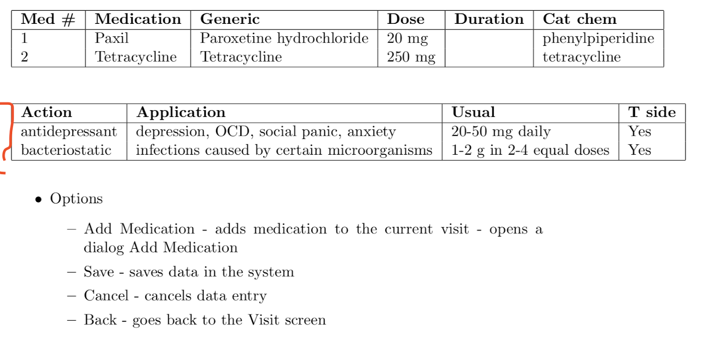

3.8 Perform Audiology Evaluation

1. The user performs **Add New Visit.**

2. The user chooses the option Add Audiology.

3. The system opens the Audiology screen.

4. The user fills out the required information.

5. The user chooses option Save.

Variation #1 Adding Audiology to an existing visit by **patient lookup**

• The user performs Lookup Patient

• The user chooses the Current Visit option.

• Go to step 2.

Variation #2 Adding Audiology to an existing visit by **visit edit**

• The user performs **Edit Visits**

• The user selects the record for the visit.

• The user chooses option Edit Visit

• Go to step 2.

**3.9 Add Pharmacology data**

1. The user performs Add New Visit.
2. The user chooses the option Add Pharmacology.
3. The system opens the Pharmacology screen.
4. The user chooses the Add Medication option.
5. The user fills out the required information.
6. The system fills out additional information, based on the user’s choice in the previous step: **Generic name, Application (disease), Chemical cate- gory, Usual dose**
7. The user closes the Add Medication window.
8. The user repeats steps 4-7 for each medication for the patient.
9. The user chooses option Save.

Variation #1 Adding Pharmacology to an existing visit by patient lookup

 • The user performs Lookup Patient

• The user chooses Current Visit option.

• Go to step 2.

Variation #2 Adding Pharmacology to an existing visit by visit edit

• The user performs Edit Visits

• The user selects the record for the visit.

• The user chooses option Edit Visit

• Go to step 2

**3.13.4 Add/edit Pharmacology Data**

1. The user enters the Main Screen.
2. The user chooses option Other.
3. The system opens the Other screen.
4. The user chooses option Dictionary data.
5. The system opens the Dictionary data screen.
6. The user chooses option Pharmacology data.
7. The system opens Pharmacology data screen
8. The user chooses the data item to add/edit and fills out/modifies the required information about the pharmacology item.
9. The user chooses the Save option.
10. The user closes the screen.

Variation #1: The user adds a new data item from the Pharmacology screen.

1. The user performs Add Pharmacology data

2. Go to step 6.

1.11.4 Pharmacology Data

* Add/Edit Medication - id, name, description, usual dose, generic, chemical category, application (disease)
* Add/Edit Generic - id, name, and description.
* Add/Edit Disease - id, name, and description.
* Add/Edit Chemical category - id, name, and description.